MODULE 1: INTRODUCTION

DATA COMMUNICATIONS
- Data Communication is defined as exchange of data between 2 devices over a transmission-medium.
- A communication-system is made up of
→ hardware (physical equipment) and
→ software (programs)
- For data-communication, the communicating-devices must be part of a communication-system.
- Four attributes of a communication-system:

Delivery
  - The system must deliver data to the correct destination.

Accuracy
  - The system must deliver the data accurately.
  - Normally, the corrupted-data are unusable.

Timeliness
  - The system must deliver audio/video data in a timely manner.
  - This kind of delivery is called real-time transmission.
  - Data delivered late are useless.

Jitter
  - Jitter refers to the variation in the packet arrival-time.
  - In other words, jitter is the uneven delay in the delivery of audio/video packets.

Components of Communication System
- Five components of a communication-system (Figure 1.1):
      - Message
      - Sender
      - Receiver
      - Transmission-Medium
      - Protocol

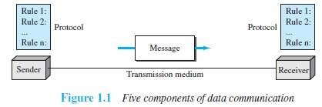

Message
  - Message is the information (or data) to be communicated.
  - Message may consist of
→ number/text
→ picture or
→ audio/video

Sender
  - Sender is the device that sends the data-message.
  - Sender can be
→ computer and
→ mobile phone

Receiver
  - Receiver is the device that receives the message.
  - Receiver can be
→ computer and
→ mobile phone

Transmission Medium
  - Transmission-medium is physical-path by which a message travels from sender to receiver.
  - Transmission-medium can be wired or wireless.
  - Examples of wired medium:
→ twisted-pair wire (used in landline telephone)
→ coaxial cable (used in cable TV network)
→ fiber-optic cable
  - Examples of wireless medium:
→ radio waves
→ microwaves
→ infrared waves (ex: operating TV using remote control)

Protocol
  - A protocol is a set of rules that govern data-communications.
  - In other words, a protocol represents an agreement between the communicating-devices.
  - Without a protocol, 2 devices may be connected but not communicating.

Data Representation
- Five different forms of information:

Text
  - Text is represented as a bit-pattern. (Bit-pattern → sequence of bits: 0s or 1s).
  - Different sets of bit-patterns are used to represent symbols (or characters).
  - Each set is called a code.
  - The process of representing symbols is called encoding.
  - Popular encoding system: ASCII, Unicode.

Number
  - Number is also represented as a bit-pattern.
  - ASCII is not used to represent number. Instead, number is directly converted to binary-form.

Image
  - Image is also represented as a bit-pattern.
  - An image is divided into a matrix of pixels (picture-elements).
  - A pixel is the smallest element of an image. (Pixel → Small dot)
  - The size of an image depends upon number of pixels (also called resolution).
For example: An image can be divided into 1000 pixels or 10,000 pixels.
  - Two types of images:

Black & White Image
¤ If an image is black & white, each pixel can be represented by a value either 0 or 1.
¤ For example: Chessboard

Color Image
¤ There are many methods to represent color images.
¤ RGB is one of the methods to represent color images.
¤ RGB is called so called ‘.’ each color is combination of 3 colors: red, green & blue.

Audio
  - Audio is a representation of sound.
  - By nature, audio is different from text, numbers, or images. Audio is continuous, not discrete.

Video
  - Video is a representation of movie.
  - Video can either
→ be produced as a continuous entity (e.g., by a TV camera), or
→ be a combination of images arranged to convey the idea of motion.

Direction of Data Flow
- Three ways of data-flow between 2 devices (Figure 1.2):
      - Simplex
      - Half-duplex
      - Full-duplex

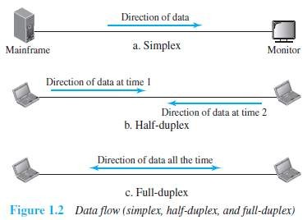

Simplex
  - The communication is unidirectional
(For ex: The simplex mode is like a one-way street).
  - On a link, out of 2 devices:
  - Only one device can transmit.
  - Another device can only receive.
  - For example (Figure 1.2a):
The monitor can only accept output.
  - Entire-capacity of channel is used to send the data in one direction.

Half-Duplex
  - Both the stations can transmit as well as receive but not at the same time.
(For ex: The half-duplex mode is like a one-lane road with 2 directional traffic).
  - When one station is sending, the other can only receive and vice-versa.
  - For example (Figure 1.2b): Walkie-talkies
  - Entire-capacity of a channel is used by one of the 2 stations that are transmitting the data.

Full-Duplex
  - Both stations can transmit and receive at the same time.
(For ex: The full-duplex is like a 2-way street with traffic flowing in both directions at the same time).
  - For example (Figure 1.2c):
Mobile phones (When 2 people are communicating by a telephone line, both can listen and talk at the same time)
  - Entire-capacity of a channel is shared by both the stations that are transmitting the data.

NETWORKS
- A network is defined as a set of devices interconnected by communication-links.
- This interconnection among computers facilitates information sharing among them.
- Computers may connect to each other by either wired or wireless media.
- Often, devices are referred to as nodes.
- A node can be any device capable of sending/receiving data in the network.
- For example: Computer & Printer
- The best-known computer network is the Internet.

Network Criteria
- A network must meet following 3 criteria’s:

Performance
  - Performance can be measured using i) Transit-time or ii) Response-time.
        - Transit Time is defined as time taken to travel a message from one device to another.
        - Response Time is defined as the time elapsed between enquiry and response.
  - The network-performance depends on following factors:
          - Number of users
          - Type of transmission-medium
          - Efficiency of software
  - Often, performance is evaluated by 2 networking-metrics: i) throughput and ii) delay.
  - Good performance can be obtained by achieving higher throughput and smaller delay times

Reliability
  - Reliability is measured by
→ frequency of network-failure
→ time taken to recover from a network-failure
→ network's robustness in a disaster
  - More the failures are, less is the network's reliability.

Security
  - Security refers to the protection of data from the unauthorized access or damage.
  - It also involves implementing policies for recovery from data-losses.

Physical Structures 1.2.2.1 Type of Connection
- Two types of connections (Figure 1.3):

Point-to-Point
  - Only two devices are connected by a dedicated-link (Figure 1.3a).
  - Entire-capacity of the link is reserved for transmission between those two devices.
  - For example: Point-to-Point connection b/w remote-control & TV for changing the channels.

Multipoint (Multi-drop)
  - Three or more devices share a single link.
  - The capacity of the channel is shared, either spatially or temporally (Figure 1.3b).
        - If link is used simultaneously by many devices, then it is spatially shared connection.
        - If user takes turns while using the link, then it is time shared (temporal) connection.
(spatially→space or temporally→time)

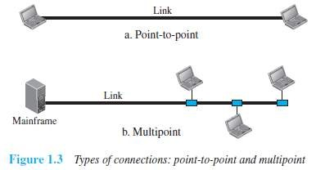

Physical Topology
- The physical-topology defines how devices are connected to make a network.
- Four basic topologies are:
        - Mesh
        - Star
        - Bus and
        - Ring

Bus Topology
- All the devices are connected to the single cable called bus (Figure 1.4).
- Every device communicates with the other device through this bus.
- A data from the source is broadcasted to all devices connected to the bus.
- Only the intended-receiver, whose physical-address matches, accepts the data.

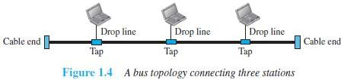

- Devices are connected to the bus by drop-lines and taps.
- A drop-line is a connection running between the device and the bus.
- A tap is a connector that links to the bus or
- Advantages:
          - Easy installation.
          - Cable required is the least compared to mesh/star topologies.
          - Redundancy is eliminated.
          - Costs less (Compared to mesh/star topologies).
          - Mostly used in small networks. Good for LAN.
- Disadvantages:
- Difficult to detect and troubleshoot fault.
- Signal reflection at the taps can cause degradation in quality.
- A fault/break in the cable stops all transmission.
- There is a limit on
  - Cable length
  - Number of nodes that can be connected.
- Security is very low because all the devices receive the data sent from the source.

Star Topology
- All the devices are connected to a central controller called a hub (Figure 1.5).
- There exists a dedicated point-to-point link between a device & a hub.
- The devices are not directly linked to one another. Thus, there is no direct traffic between devices.
- The hub acts as a junction:
If device-1 wants to send data to device-2,
the device-1 sends the data to the hub,
then the hub relays the data to the device-2.

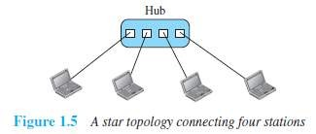
- Advantages:
          - Less expensive: Each device needs only one link & one I/O port to connect it to any devices.
          - Easy installation & reconfiguration: Nodes can be added/removed w/o affecting the network.
          - Robustness: If one link fails, it does not affect the entire system.
          - Easy to detect and troubleshoot fault.
          - Centralized management: The hub manages and controls the whole network.
- Disadvantages:
- Single point of failure: If the hub goes down, the whole network is dead.
- Cable length required is the more compared to bus/ring topologies.
- Number of nodes in network depends on capacity of hub.

Ring Topology
- Each device is connected to the next, forming a ring (Figure 1.6).
- There are only two neighbors for each device.
- Data travels around the network in one direction till the destination is reached.
- Sending and receiving of data takes place by the help of token.
- Each device has a repeater.
- A repeater
→ receives a signal on transmission-medium &
→ regenerates & passes the signal to next device.

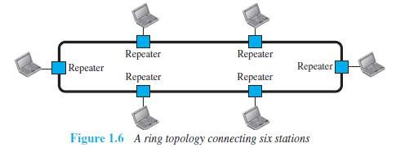

- Advantages:
          - Easy installation and reconfiguration.
To add/delete a device, requires changing only 2 connections.
3) Fault isolation is simplified.
If one device does not receive a signal within a specified period, it can issue an alarm.
The alarm alerts the network-operator to the problem and its location.
3) Congestion reduced: Because all the traffic flows in only one direction.
- Disadvantages:
- Unidirectional traffic.
- A fault in the ring/device stops all transmission.
The above 2 drawbacks can be overcome by using dual ring.
- There is a limit on
  - Cable length &
  - Number of nodes that can be connected.
- Slower: Each data must pass through all the devices between source and destination.

Mesh Topology
- All the devices are connected to each other (Figure 1.7).
- There exists a dedicated point-to-point link between all devices.
- There are n(n-1) physical channels to link n devices.
- Every device not only sends its own data but also relays data from other nodes.
- For ‘n’ nodes,
→ there are n(n-1) physical-links
→ there are n(n-1)/2 duplex-mode links
- Every device must have (n–1) I/O ports to be connected to the other (n-1) devices.

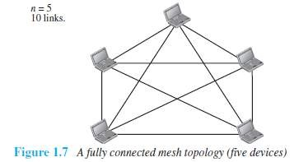

- Advantages:
          - Congestion reduced: Each connection can carry its own data load.
          - Robustness: If one link fails, it does not affect the entire system.
          - Security: When a data travels on a dedicated-line, only intended-receiver can see the data.
          - Easy fault identification & fault isolation: Traffic can be re-routed to avoid problematic links.
- Disadvantages:
- Difficult installation and reconfiguration.
- Bulk of wiring occupies more space than available space.
- Very expensive: as there are many redundant connections.
- Not mostly used in computer networks. It is commonly used in wireless networks.
- High redundancy of the network-connections.

Network Types
- Two popular types of networks:
- LAN (Local Area Network) &
- WAN (Wide Area Network)

LAN
- LAN is used to connect computers in a single office, building or campus (Figure 1.8).
- LAN is usually privately owned network.
- A LAN can be simple or complex.
      - Simple: LAN may contain 2 PCs and a printer.
      - Complex: LAN can extend throughout a company.
- Each host in a LAN has an address that uniquely defines the host in the LAN.
- A packet sent by a host to another host carries both source host’s and destination host’s addresses.
- LANs use a smart connecting switch.
- The switch is able to
→ recognize the destination address of the packet &
→ guide the packet to its destination.
- The switch
→ reduces the traffic in the LAN &
→ allows more than one pair to communicate with each other at the same time.
- Advantages:

Resource Sharing
  - Computer resources like printers and hard disks can be shared by all devices on the network.

Expansion
  - Nowadays, LANs are connected to WANs to create communication at a wider level.

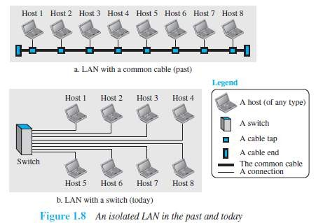

WAN
- WAN is used to connect computers anywhere in the world.
- WAN can cover larger geographical area. It can cover cities, countries and even continents.
- WAN interconnects connecting devices such as switches, routers, or modems.
- Normally, WAN is
→ created & run by communication companies (Ex: BSNL, Airtel)
→ leased by an organization that uses it.
- A WAN can be of 2 types:

Point-to-point WAN
  - A point-to-point WAN is a network that connects 2 communicating devices through a transmission media (Figure 1.9).

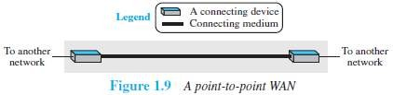

Switched WAN
  - A switched WAN is a network with more than two ends.
  - The switched WAN can be the backbones that connect the Internet.
  - A switched WAN is a combination of several point-to-point WANs that are connected by switches (Figure 1.10).

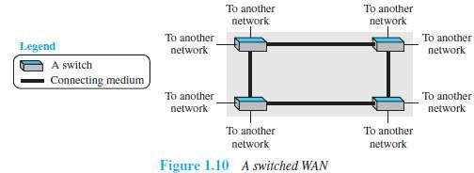

Internetwork
- A network of networks is called an internet. (Internet → inter-network) (Figure 1.12).
- For example (Figure 1.11):
  - Assume that an organization has two offices,
        - First office is on the east coast &
        - Second office is on the west coast.
  - Each office has a LAN that allows all employees in the office to communicate with each other.
  - To allow communication between employees at different offices, the management leases a point-to-point dedicated WAN from a ISP and connects the two LANs.
(ISP → Internet service provider such as a telephone company ex: BSNL).

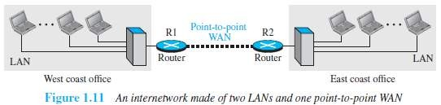

  - When a host in the west coast office sends a message to another host in the same office, the router blocks the message, but the switch directs the message to the destination.
  - On the other hand, when a host on the west coast sends a message to a host on the east coast, router R1 routes the packet to router R2, and the packet reaches the destination.

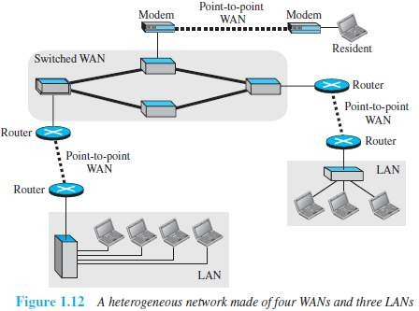

LAN vs. WAN
Parameters | LAN | WAN
Expands to | Local Area Network | Wide Area Network
Meaning | LAN is used to connect computers in a single office, building or  campus | WAN is used to connect computers in a large geographical area such  as countries
Ownership of network | Private | Private or public
Range | Small: up to 10 km | Large: Beyond 100 km
Speed | High: Typically 10, 100 and 1000  Mbps | Low: Typically 1.5 Mbps
Propagation Delay | Short | Long
Cost | Low | High
Congestion | Less | More
Design & maintenance | Easy | Difficult
Fault Tolerance | More Tolerant | Less Tolerant
Media used | Twisted pair | Optical fiber or radio waves
Used for | College, Hospital | Internet
Interconnects | LAN interconnects hosts | WAN interconnects connecting devices such as switches, routers, or modems

Switching
- An internet is a switched network in which a switch connects at least two links together.
- A switch needs to forward data from a network to another network when required.
- Two types of switched networks are 1) circuit-switched and 2) packet-switched networks.

Circuit-Switched Network
- A dedicated connection, called a circuit, is always available between the two end systems.
- The switch can only make it active or inactive.

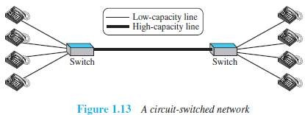

¤ As shown in Figure 1.13, the 4 telephones at each side are connected to a switch.
¤ The switch connects a telephone at one side to a telephone at the other side.
¤ A high-capacity line can handle 4 voice communications at the same time.
¤ The capacity of high line can be shared between all pairs of telephones.
¤ The switch is used for only forwarding.
- Advantage:
A circuit-switched network is efficient only when it is working at its full capacity.
- Disadvantage:
Most of the time, the network is inefficient because it is working at partial capacity.

Packet-Switched Network
- In a computer network, the communication between the 2 ends is done in blocks of data called packets.
- The switch is used for both storing and forwarding because a packet is an independent entity
that can be stored and sent later.

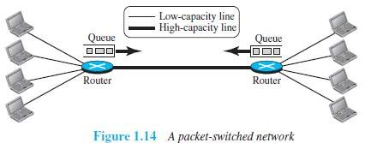

¤ As shown in Figure 1.14, the 4 computers at each side are connected to a router.
¤ A router has a queue that can store and forward the packet.
¤ The high-capacity line has twice the capacity of the low-capacity line.
¤ If only 2 computers (one at each site) need to communicate with each other, there is no waiting for the packets.
¤ However, if packets arrive at one router when high-capacity line is at its full capacity, the packets should be stored and forwarded.
- Advantages:
A packet-switched network is more efficient than a circuit switched network.
- Disadvantage:
The packets may encounter some delays.

The Internet Today
- A network of networks is called an internet. (Internet → inter-network)
- Internet is made up of (Figure 1.15)
- Backbones
- Provider networks &
- Customer networks

Backbones
  - Backbones are large networks owned by communication companies such as BSNL and Airtel.
  - The backbone networks are connected through switching systems, called peering points.

Provider Networks
  - Provider networks use the services of the backbones for a fee.
  - Provider networks are connected to backbones and sometimes to other provider networks.

Customer Networks
  - Customer networks actually use the services provided by the Internet.
  - Customer networks pay fees to provider networks for receiving services.
- Backbones and provider networks are also called Internet Service Providers (ISPs).
- The backbones are often referred to as international ISPs.
The provider networks are often referred to as national or regional ISPs.

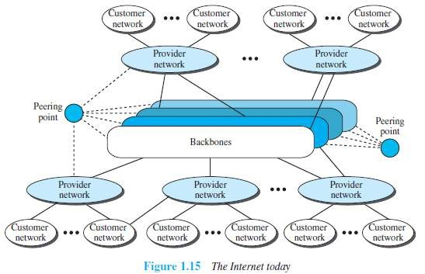

Accessing the Internet
- The Internet today is an internetwork that allows any user to become part of it.
- However, the user needs to be physically connected to an ISP.
- The physical connection is normally done through a point-to-point WAN.

Using Telephone Networks
  - Most residences have telephone service, which means they are connected to a telephone network.
  - Most telephone networks have already connected themselves to the Internet.
  - Thus, residences can connect to the Internet using a point-to-point WAN.
  - This can be done in two ways:

Dial-up service
¤ A modem can be added to the telephone line.
¤ A modem converts data to voice.
¤ The software installed on the computer
→ dials the ISP &
→ imitates making a telephone connection.
¤ Disadvantages:
    - The dial-up service is very slow.
    - When line is used for Internet connection, it cannot be used for voice connection.
    - It is only useful for small residences.

DSL Service
¤ DSL service also allows the line to be used simultaneously for voice & data communication.
¤ Some telephone companies have upgraded their telephone lines to provide higher
speed Internet services to residences.

Using Cable Networks
  - A residence can be connected to the Internet by using cable service.
  - Cable service provides a higher speed connection.
  - The speed varies depending on the number of neighbors that use the same cable.

Using Wireless Networks
  - A residence can use a combination of wireless and wired connections to access the Internet.
  - A residence can be connected to the Internet through a wireless WAN.

Direct Connection to the Internet
  - A large organization can itself become a local ISP and be connected to the Internet.
  - The organization
→ leases a high-speed WAN from a carrier provider and
→ connects itself to a regional ISP.

MODULE 1(CONT.): NETWORK MODELS

PROTOCOL LAYERING
- A protocol defines the rules that both the sender and receiver and all intermediate devices need to follow to be able to communicate effectively.
- When communication is simple, we may need only one simple protocol.
When communication is complex, we need to divide the task b/w different layers. We need a protocol at each layer, or protocol layering.

Scenarios First Scenario
- In the first scenario, communication is so simple that it can occur in only one layer (Figure 2.1).
- Assume Maria and Ann are neighbors with a lot of common ideas.
- Communication between Maria and Ann takes place in one layer, face to face, in the same language

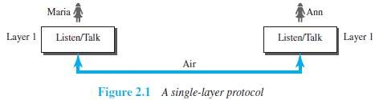

Second Scenario
- Maria and Ann communicate using regular mail through the post office (Figure 2.2).
- However, they do not want their ideas to be revealed by other people if the letters are intercepted.
- They agree on an encryption/decryption technique.
- The sender of the letter encrypts it to make it unreadable by an intruder; the receiver of the letter
decrypts it to get the original letter.

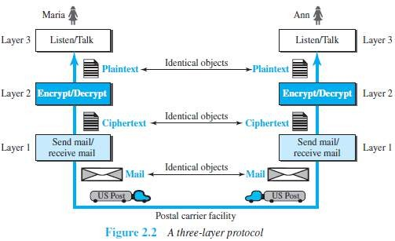

Protocol Layering
- Protocol layering enables us to divide a complex task into several smaller and simpler tasks.
- Modularity means independent layers.
- A layer (module) can be defined as a black box with inputs and outputs, without concern about how inputs are changed to outputs.
- If two machines provide the same outputs when given the same inputs, they can replace each other.
- Advantages:
        - It allows us to separate the services from the implementation.
        - There are intermediate systems that need only some layers, but not all layers.
- Disadvantage:
1) Having a single layer makes the job easier. There is no need for each layer to provide a service to the upper layer and give service to the lower layer.

Principles of Protocol Layering

First Principle
- If we want bidirectional communication, we need to make each layer able to perform 2 opposite tasks, one in each direction.
- For example, the third layer task is to listen (in one direction) and talk (in the other direction).

Second Principle
- The two objects under each layer at both sites should be identical.
- For example, the object under layer 3 at both sites should be a plaintext letter.

Logical Connections
- We have layer-to-layer communication (Figure 2.3).
- There is a logical connection at each layer through which 2 end systems can send the object created from that layer.

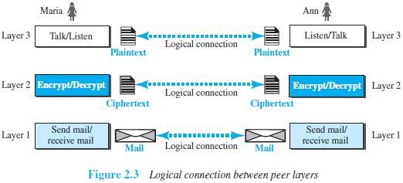

TCP/IP PROTOCOL SUITE
- TCP/IP is a protocol-suite used in the Internet today.
- Protocol-suite refers a set of protocols organized in different layers.
- It is a hierarchical protocol made up of interactive modules, each of which provides a specific functionality.
- The term hierarchical means that each upper level protocol is supported by the services provided by
one or more lower level protocols.

Layered Architecture

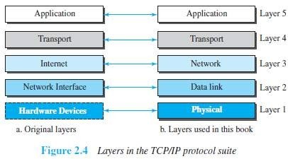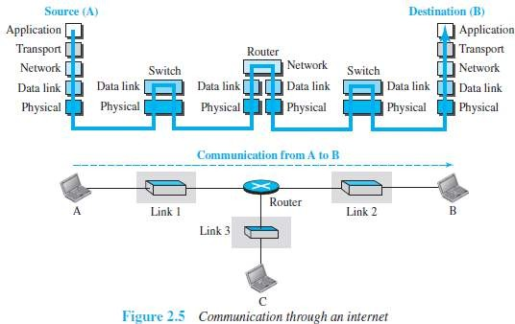

- Let us assume that computer A communicates with computer B (Figure 2.4).
- As the Figure 2.5 shows, we have five communicating devices:
1) Source host(computer A) 2) Link-layer switch in link 1
3) Router 4) Link-layer switch in link 2
5) Destination host (computer B).
- Each device is involved with a set of layers depending on the role of the device in the internet.
- The two hosts are involved in all five layers.
- The source host
→ creates a message in the application layer and
→ sends the message down the layers so that it is physically sent to the destination host.
- The destination host
→ receives the message at the physical layer and
→ then deliver the message through the other layers to the application layer.
- The router is involved in only three layers; there is no transport or application layer.
- A router is involved in n combinations of link and physical layers.
where n = number of links the router is connected to.
- The reason is that each link may use its own data-link or physical protocol.
- A link-layer switch is involved only in two layers: i) data-link and ii) physical.

Layers in the TCP/IP Protocol Suite

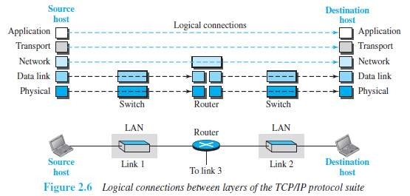

- As shown in the figure 2.6, the duty of the application, transport, and network layers is end-to-end.
- However, the duty of the data-link and physical layers is hop-to-hop. A hop is a host or router.
- The domain of duty of the top three layers is the internet.
The domain of duty of the two lower layers is the link.
- In top 3 layers, the data unit should not be changed by any router or link-layer switch.
In bottom 2 layers, the data unit is changed only by the routers, not by the link-layer switches.

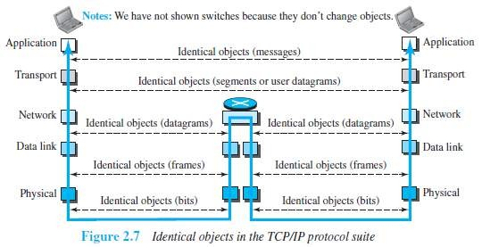

- Identical objects exist between two hops. Because router may fragment the packet at the network layer and send more packets than received (Figure 2.7).
- The link between two hops does not change the object.

Description of Each Layer Physical Layer
- The physical layer is responsible for movements of individual bits from one node to another node.
- Transmission media is another hidden layer under the physical layer.
- Two devices are connected by a transmission medium (cable or air).
- The transmission medium does not carry bits; it carries electrical or optical signals.
- The physical layer
→ receives bits from the data-link layer &
→ sends through the transmission media.

Data Link Layer
- Data-link-layer (DLL) is responsible for moving frames from one node to another node over a link.
- The link can be wired LAN/WAN or wireless LAN/WAN.
- The data-link layer
→ gets the datagram from network layer
→ encapsulates the datagram in a packet called a frame.
→ sends the frame to physical layer.
- TCP/IP model does not define any specific protocol.
- DLL supports all the standard and proprietary protocols.
- Each protocol may provide a different service.
- Some protocols provide complete error detection and correction; some protocols provide only error correction.

Network Layer
- The network layer is responsible for source-to-destination transmission of data.
- The network layer is also responsible for routing the packet.
- The routers choose the best route for each packet.
- Why we need the separate network layer?
- The separation of different tasks between different layers.
- The routers do not need the application and transport layers.
- TCP/IP model defines 5 protocols:
1) IP (Internetworking Protocol) 2) ARP (Address Resolution Protocol)
3) ICMP (Internet Control Message Protocol) 4) IGMP (Internet Group Message Protocol)

IP
  - IP is the main protocol of the network layer.
  - IP defines the format and the structure of addresses.
  - IP is also responsible for routing a packet from its source to its destination.
  - It is a connection-less & unreliable protocol.
  - Connection-less means there is no connection setup b/w the sender and the receiver.
  - Unreliable protocol means
→ IP does not make any guarantee about delivery of the data.
→ Packets may get dropped during transmission.
  - It provides a best-effort delivery service.
  - Best effort means IP does its best to get the packet to its destination, but with no guarantees.
  - IP does not provide following services
→ flow control
→ error control
→ congestion control services.
  - If an application requires above services, the application should rely only on the transport- layer protocol.

ARP
  - ARP is used to find the physical-address of the node when its Internet-address is known.
  - Physical address is the 48-bit address that is imprinted on the NIC or LAN card.
  - Internet address (IP address) is used to uniquely & universally identify a device in the internet.

ICMP
  - ICMP is used to inform the sender about datagram-problems that occur during transit.

IGMP
  - IGMP is used to send the same message to a group of recipients.

Transport Layer
- TL protocols are responsible for delivery of a message from a process to another process.
- The transport layer
→ gets the message from the application layer
→ encapsulates the message in a packet called a segment and
→ sends the segment to network layer.
- TCP/IP model defines 3 protocols:1) TCP (Transmission Control Protocol)
- UDP (User Datagram Protocol) &
- SCTP (Stream Control Transmission Protocol)

TCP
  - TCP is a reliable connection-oriented protocol.
  - A connection is established b/w the sender and receiver before the data can be transmitted.
  - TCP provides
→ flow control
→ error control and
→ congestion control

UDP
  - UDP is the simplest of the 3 transport protocols.
  - It is an unreliable, connectionless protocol.
  - It does not provide flow, error, or congestion control.
  - Each datagram is transported separately & independently.
  - It is suitable for application program that
→ needs to send short messages &
→ cannot afford the retransmission.

SCTP
  - SCTP provides support for newer applications such as voice over the Internet.
  - It combines the best features of UDP and TCP.

Application Layer
- The two application layers exchange messages between each other.
- Communication at the application layer is between two processes (two programs running at this layer).
- To communicate, a process sends a request to the other process and receives a response.
- Process-to-process communication is the duty of the application layer.
- TCP/IP model defines following protocols:
- SMTP is used to transport email between a source and destination.
- TELNET is used for accessing a site remotely.
- FTP is used for transferring files from one host to another.
- DNS is used to find the IP address of a computer.
- SNMP is used to manage the Internet at global and local levels.
- HTTP is used for accessing the World Wide Web (WWW).

(FTP → File Transfer Protocol SMTP → Simple Mail Transfer Protocol) (DNS → Domain Name System HTTP → Hyper Text Transfer Protocol) (SNMP → Simple Network Management Protocol TELNET → Terminal Network)

Encapsulation and Decapsulation

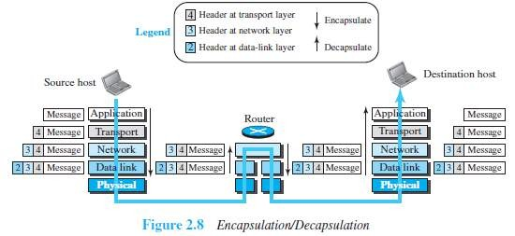

Encapsulation at the Source Host
- At the source, we have only encapsulation (Figure 2.8).
  - At the application layer, the data to be exchanged is referred to as a message.
  - A message normally does not contain any header or trailer.
  - The message is passed to the transport layer.
  - The transport layer takes the message as the payload.
  - TL adds its own header to the payload.
  - The header contains
→ identifiers of the source and destination application programs
→ information needed for flow, error control, or congestion control.
  - The transport-layer packet is called the segment (in TCP) and the user datagram (in UDP).
  - The segment is passed to the network layer.
  - The network layer takes the transport-layer packet as payload.
  - NL adds its own header to the payload.
  - The header contains
→ addresses of the source and destination hosts
→ some information used for error checking of the header &
→ fragmentation information.
  - The network-layer packet is called a datagram.
  - The datagram is passed to the data-link layer.
  - The data-link layer takes the network-layer packet as payload.
  - DLL adds its own header to the payload.
  - The header contains the physical addresses of the host or the next hop (the router).
  - The link-layer packet is called a frame.
  - The frame is passed to the physical layer for transmission

Decapsulation and Encapsulation at the Router
- At the router, we have both encapsulation & encapsulation and because the router is connected to two or more links.
  - Data-link layer
→ receives frame from physical layer
→ decapsulates the datagram from the frame and
→ passes the datagram to the network layer.
  - The network layer
→ inspects the source and destination addresses in the datagram header and
→ consults forwarding table to find next hop to which the datagram is to be delivered.
  - The datagram is then passed to the data-link layer of the next link.
  - The data-link layer of the next link
→ encapsulates the datagram in a frame and
→ passes the frame to the physical layer for transmission.

Decapsulation at the Destination Host
- At the destination host, each layer
→ decapsulates the packet received from lower layer
→ removes the payload and
→ delivers the payload to the next-higher layer

Addressing
- We have logical communication between pairs of layers.
- Any communication that involves 2 parties needs 2 addresses: source address and destination address.
- We need 4 pairs of addresses (Figure 2.9):
- At the application layer, we normally use names to define
→ site that provides services, such as vtunotesbysri.com, or
→ e-mail address, such as vtunotesbysree@gmail.com.
- At the transport layer, addresses are called port numbers.
  - Port numbers define the application-layer programs at the source and destination.
  - Port numbers are local addresses that distinguish between several programs running at the same time.
- At the network-layer, addresses are called IP addresses.
  - IP address uniquely defines the connection of a device to the Internet.
  - The IP addresses are global, with the whole Internet as the scope.
- At the data link-layer, addresses are called MAC addresses
  - The MAC addresses defines a specific host or router in a network (LAN or WAN).
  - The MAC addresses are locally defined addresses.

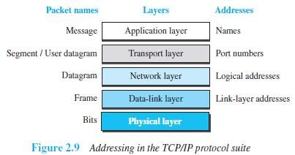

Multiplexing and Demultiplexing
- Multiplexing means a protocol at a layer can encapsulate a packet from several next-higher layer protocols (one at a time) (Figure 2.10).
- Demultiplexing means a protocol can decapsulate and deliver a packet to several next-higher layer
protocols (one at a time).
- At transport layer, either UDP or TCP can accept a message from several application-layer protocols.
- At network layer, IP can accept
→ a segment from TCP or a user datagram from UDP.
→ a packet from ICMP or IGMP.
- At data-link layer, a frame may carry the payload coming from IP or ARP.

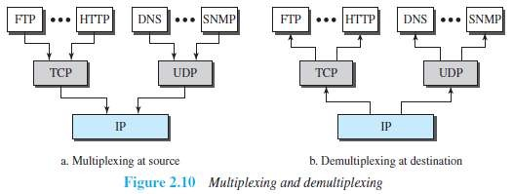

OSI MODEL
- OSI model was developed by ISO.
- ISO is the organization, OSI is the model.
- Purpose: OSI was developed to allow systems with diff. platforms to communicate with each other.
- Platform means hardware, software or operating system.
- OSI is a network-model that defines the protocols for network communications.
- OSI has 7 layers as follows (Figure 2.11):
- Application Layer
- Presentation Layer
- Session Layer
- Transport Layer
- Network Layer
- Data Link Layer
- Physical Layer
- Each layer has specific duties to perform and has to co-operate with the layers above & below it.

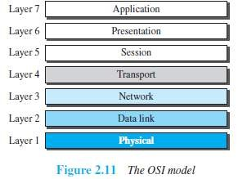

OSI vs. TCP/IP
- The four bottommost layers in the OSI model & the TCP/IP model are same (Figure 2.12).
However, the Application-layer of TCP/IP model corresponds to the Session, Presentation
& Application Layer of OSI model.
Two reasons for this are:
  - TCP/IP has more than one transport-layer protocol.
  - Many applications can be developed at Application layer
- The OSI model specifies which functions belong to each of its layers.
In TCP/IP model, the layers contain relatively independent protocols that can be mixed and matched depending on the needs of the system.

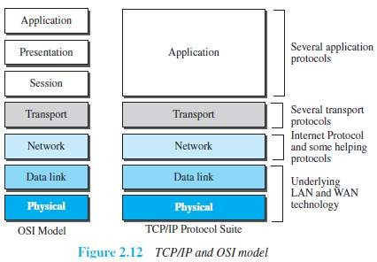

Lack of OSI Model’s Success
- OSI was completed when TCP/IP was fully in place and a lot of time and money had been spent on the suite; changing it would cost a lot.
- Some layers in the OSI model were never fully defined.
- When OSI was implemented by an organization in a different application, it did not show a high
enough level of performance

